1. <http://numbersapi.com/#42>

<http://numbersapi.com/random/year?json>

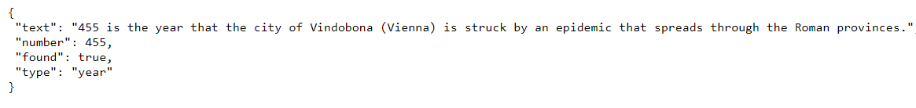

<http://numbersapi.com/26/date>



1. <http://www.boredapi.com/documentation>

<http://www.boredapi.com/api/activity/>



<http://www.boredapi.com/api/activity?key=5881028>

